Giant Pepper Boxes converse among themselves.

An interactive Pepper Box plays mostly pepper-related songs and speech and then passes the torch to the next Box.
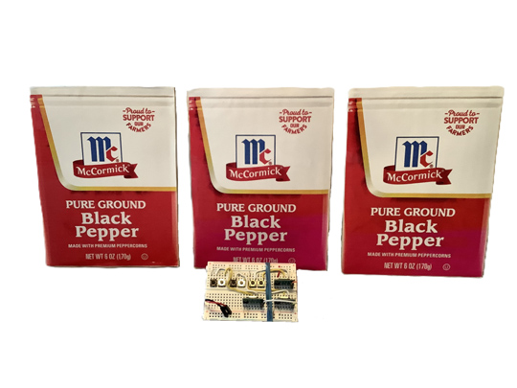
Components and supplies
4
5V regulator (low dropout)
2
433MHz Transmitter and Receiver
6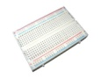
Breadboard - 400 contacts
1
push button switch
1
DPDT switch
3
Battery NiMH 6V, 2.7A-H
1
Battery Charger
1
adapter cable for battery charger
1
5.5mm socket and jack
3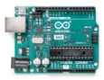
Arduino Uno Rev3
3
3W stereo amplifier
3
speaker 2" diameter
3
DFPlayer Mini MP3 player
Tools and machines
1
Drill Press
1
Band Saw
1
Hole Saw
1
Table Saw
1
Electric Sander
Apps and platforms
1
Audacity
1
Arduino_IDE 2.3.6
Project description
Pepper is a subject worthy of celebration. These radio-controlled, interactive boxes play mostly pepper-themed audio, including “Stone Love” by the Pepper, “Black Pepper” by the Yoruba Singers and 8 other songs, as well as 32 user-generated short audio MP3's from Audacity.
This project consists of three giant wooden pepper boxes and a remote control to start them. Once one of the pepper boxes is triggered with a radio signal from the control, the pepper box plays sound clips; then the box sends a radio signal to the next pepper box which then responds by playing responsive related clips. This continues for a while. There are 12 different sequences in the project; each sequence involves all 3 boxes. Each box has an Arduino Uno, two radio receivers, one radio transmitter, an MP3 player, a dual audio amplifier, two speakers and a battery.
The key components in this project are the 433MHz radio receivers which can be paired with one or more 433MHz transmitters. These super-inexpensive radios are slow as can be (300ms to receive a single bit), which determines the speed at which the software can operate. This results in a delay of several seconds between when one Pepper Box transmits a three-bit word and the next box responds. This delay is OK because a full cycle of the Boxes interacting can take over five minutes; some songs are over three minutes long.
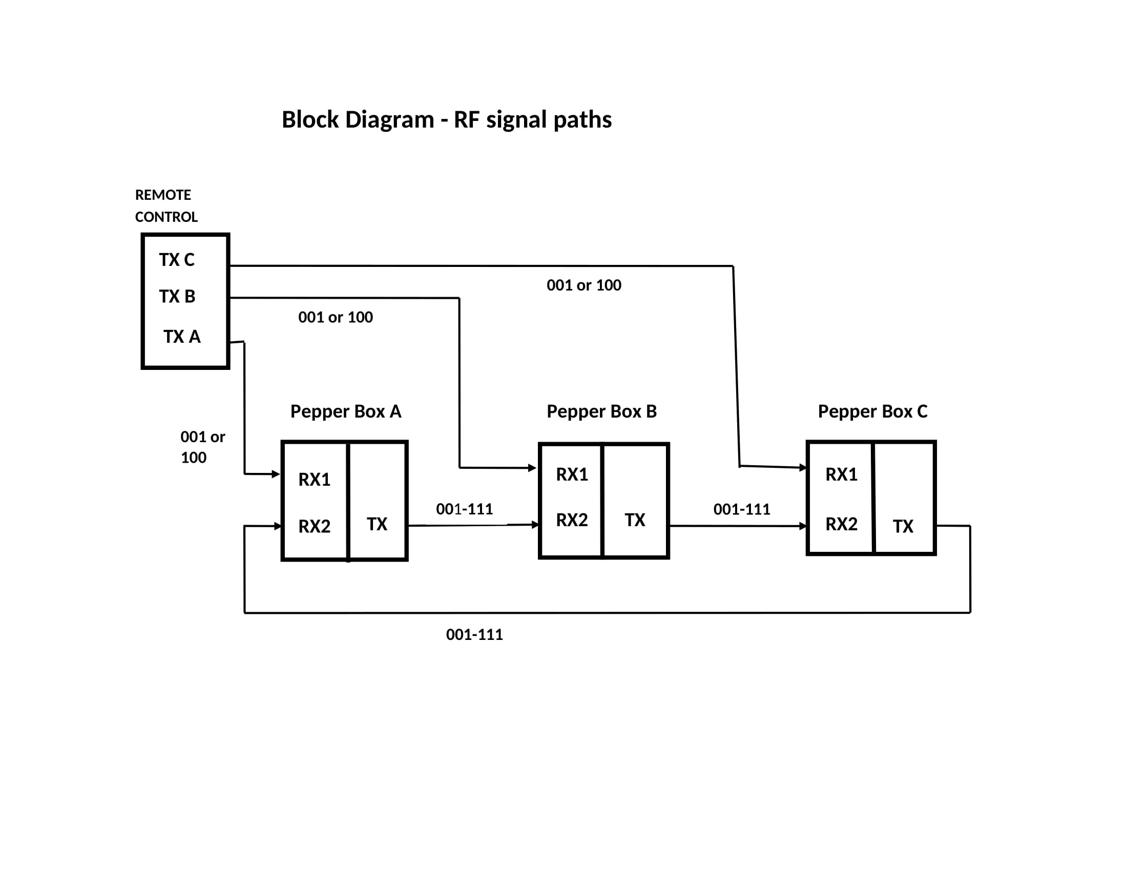
This project consists of a tiresome (but worth it) number of stages:
- Pair the six sets of radio receivers with their transmitter
- Build the remote control used to start the boxes
- Load the sound clips into the SD cards
- Assemble the electronics on the wooden base and wire them,
- Load the Arduino programs and test. Revise programs if desired.
- Complete the wooden boxes and install the remaining parts.
- Enjoy the awesome results and bask in adulation from family and friends.
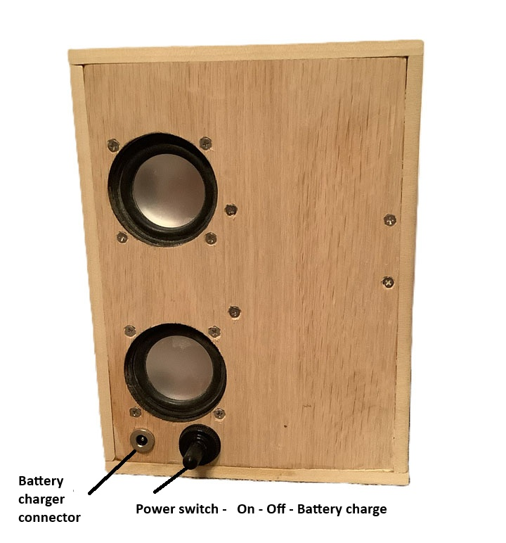
- Pair the six sets of radio receivers with their transmitters
The Qiachip RX480-E4 receivers have the capability of being matched with a Qiachip TX118SA-4 transmitter. To match the six pairs, build a pair of breadboards. The breadboards are shown in the below illustrations.
The first view is the circuit used for the transmitters. The transmitter operates from a 9V battery. The four switches are used to transmit the D0, D1, D2, and D3 signals. Add a wire for an antenna as shown. There were not Fritzing models available at this time of the RX and TX modules, so they are shown as outlines.
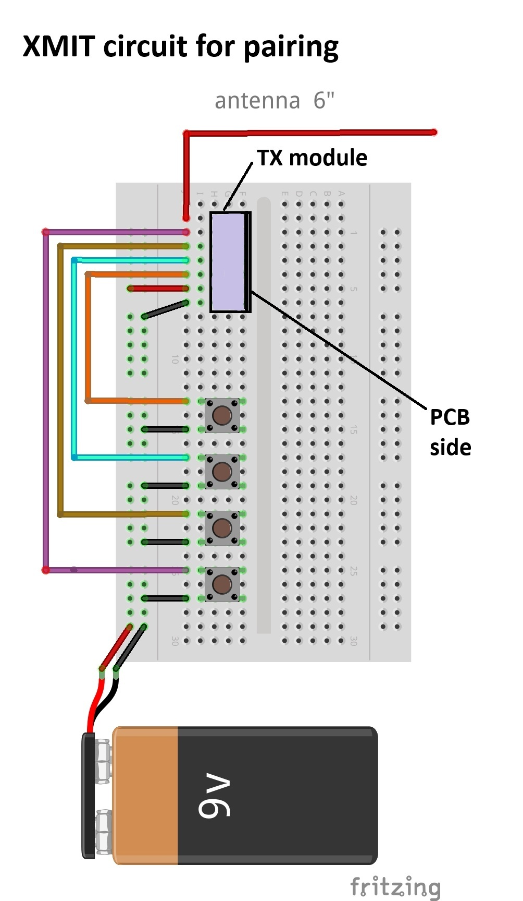
This view below is the Receiver pairing circuit. Solder the antennas on the 6 receivers The voltage regulator converts the 9V battery voltage to +5V needed by the receiver. The resistor values are not critical, I used 1K. When testing the D0, D1, D2, and D3 signals, you may notice that the D2 and D3 LED's are reversed. I think there is a typo on the data sheet. Don't be concerned, the Arduino program corrects for this. Only 3 of the 4 radio channels are used in this project. 001 thru 111 introduce enough complexity!
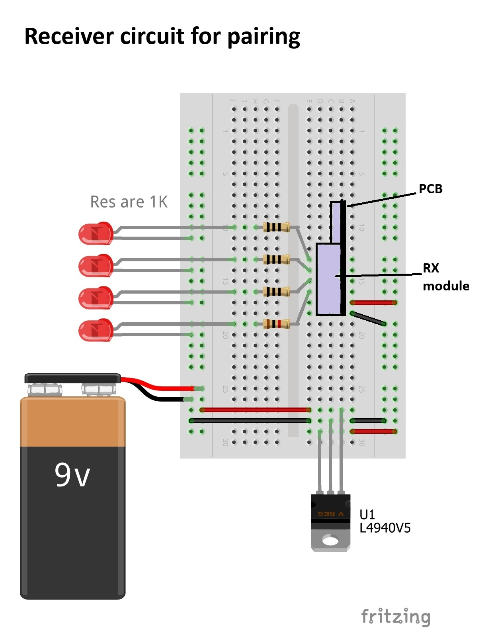
This photo gallery includes photos of the breadboards of the TX training, RX training and Remote Control.
﻿
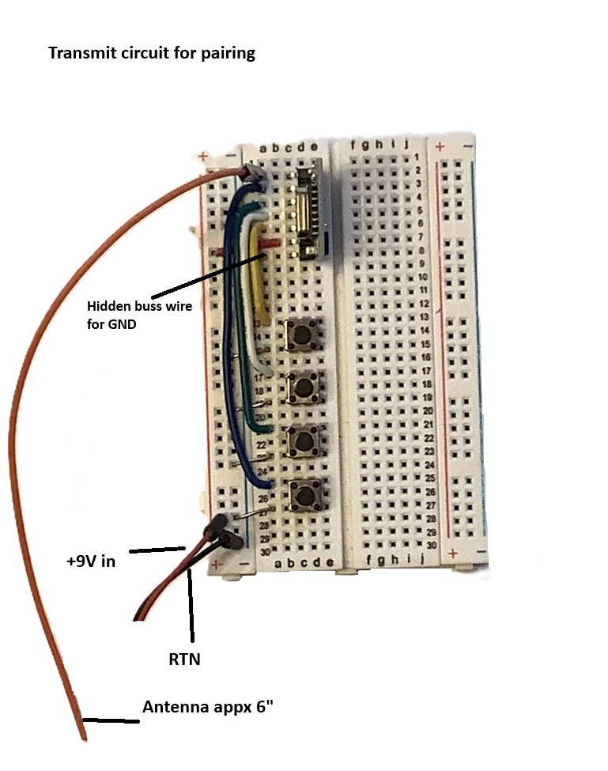
PreviousNext
Programming the pair consists of.
- Power up both breadboards
- Reset the receiver module by pressing the learning button on the receiver module 8 times. The onboard LED will flash 7 times.
- Press the learning button one time to put the receiver into Momentary Mode.
- Press any switch on the transmit breadboard. The corresponding LED in the receiver breadboard will light.
- Verify that all four switches on the transmit light up their corresponding LED on the receiver breadboard.
- Mark the pairs as follows as shown. This is a big opportunity for problems if the parts get confused.
Pair TX marking Used on RX marking Used on
1 A remote RX1-A box A
2 B remote RX1-B box B
3 C remote RX1-C box C
4 box A box A RX2-B box B
5 box B box B RX2-C box C
6 box C box C RX2-A box A
Note that you can pair a receiver with more than one transmitter. To add another transmitter just push the learning mode button once and then have the new transmitter send a signal. The trick is to not reset the receiver which would erase the previous pairing. The Pepper Box project is linked to another project this way.
- Build the controller used to start the boxes
The transmitters will operate directly from a 9V battery. Install the "A", "B", "C" transmitters and the 6 push-button switches as shown in the illustration. Make the antenna wires about 6". Also shown in the photo are the push buttons that transmit "001" and "100" on transmitter C. These signals are received by Pepper Box "C" and start the fateful interactions.
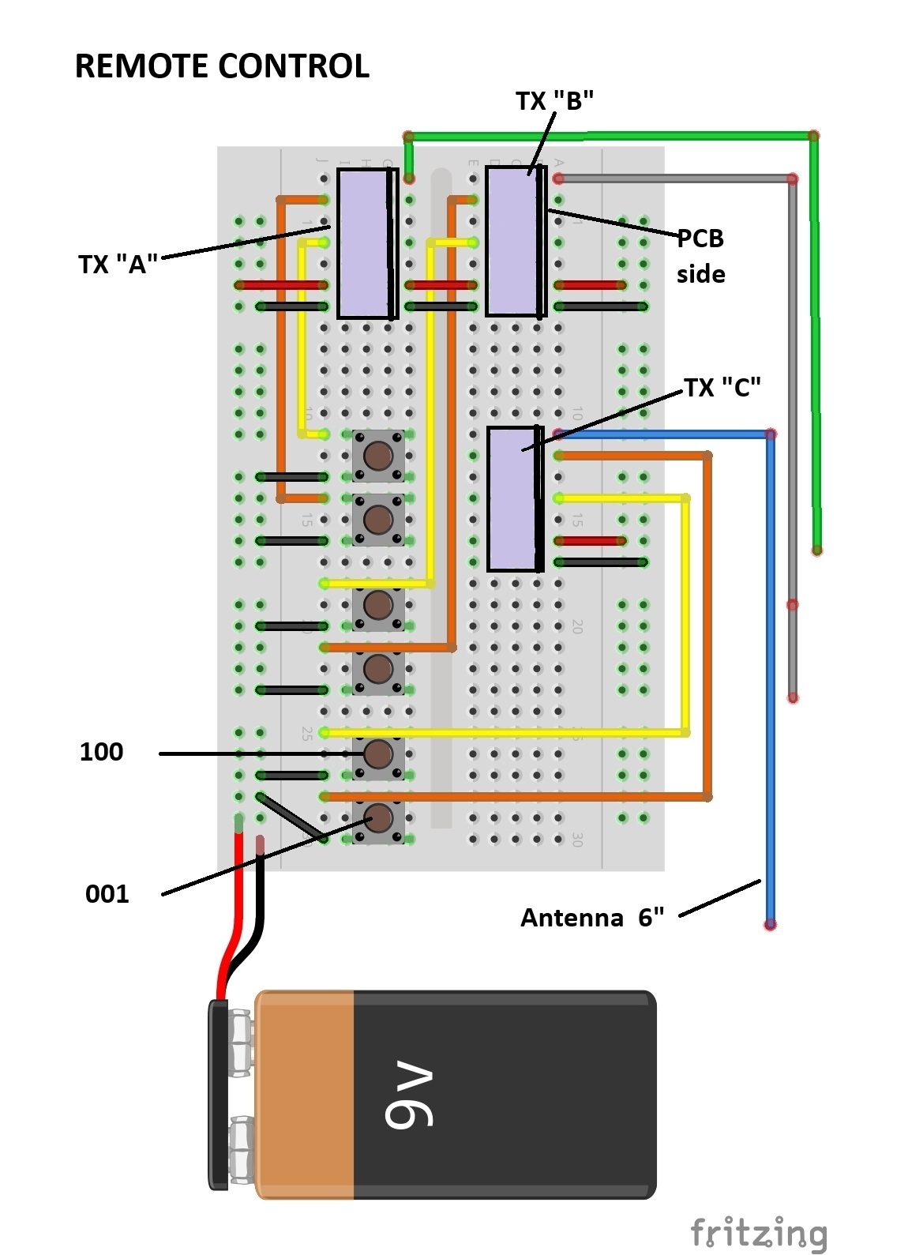
Load the sound clips into the SD cards
This is where the fun begins! I tried to have some of the dialog on the pepper boxes consist of one box responding to the previous box. It's tricky because a box generally has two alternating responses to a binary word from the previous box. You can use my sound clips or make your own. Any songs you must purchase yourself. I bought the songs I used (for example "Beverly Hills" by Weezer) from ITunes. I then saved it in MP3 in ITunes and copied it into Audacity and then into the SD cards. The files loaded into the SD card must be in a directory "MP3". There are 42 MP3 clips used. 32 of the sound clips used are in the file "MP3_Pepper"found with the link below. The other 10 sound clips are the purchased songs.
Here's an example of one of interactions:
Remote Control Press button C "100"
Pepper Box C
"Did you say something? I thought I heard something?" - Steve's voice
"Not me, but here's a weird dog" - Becky's voice
Cat meows.
Pepper Box A
"Pepper box, black pepper box" - Becky' voice
"Make with premium peppercorns" - Steve's voice
Pepper Box B
"Here's Stone Love by Pepper" - Becky's voice
Stone Love by Pepper plays
Pepper Box C
Two Bird calls
"Is that those damn birds again?" - Becky's voice
Pepper Box A
What's Up? by Four Non-Blondes plays.
End of interactions.
The MP3 audio clips are $ here $
The scripts for the audio clips are $ here $
- Assemble the electronics on the wooden base and wire them
First, cut the wooden parts needed to build the boxes. All wood is 1/4" thick and widths are standard as purchased from Home Depot. Base and front piece are 5.5" wide by 7.5" long, 6 pieces are needed for 3 boxes (I used oak). The top and bottom are 3.5" wide by 6" long, 6 pieces needed (I used poplar). Side pieces are3.5" wide by 7.5" long, 6 pieces needed (poplar again). The finished box is 8" tall by 6" wide by 3.5" deep. There are a bunch of 1/4" X 1/4" pieces used to support the front cover. Cut 6 pieces appx 6" long and 6 pieces appx 4.5" long. For now put all of the wooden pieces aside except for one 5.5" X 7.5" piece for the base of Pepper Box A.
In the photos below, ignore the walls of the box; I didn't take the photos until the project was finished. The walls will be installed much later.
Mark the base and drill the holes needed to mount the components as shown. The holes that mount the speakers and the Arduino need to be #4 countersunk. Note that you should mount the two speakers more toward the left side of the box than I did, otherwise you'll have to shorten the breadboards on a band saw. This is a pain and can result in shorting out the + and RTN conductors. The holes for the speaker cones require a 2" diameter hole saw. Drill the mounting holes for the DPDT switch and battery charging connector. Do not install them yet. They protrude out and make it more difficult to glue the box together.
Install the parts on the breadboards and glue them in place using their adhesive backing. Also install the speakers and the Arduino.
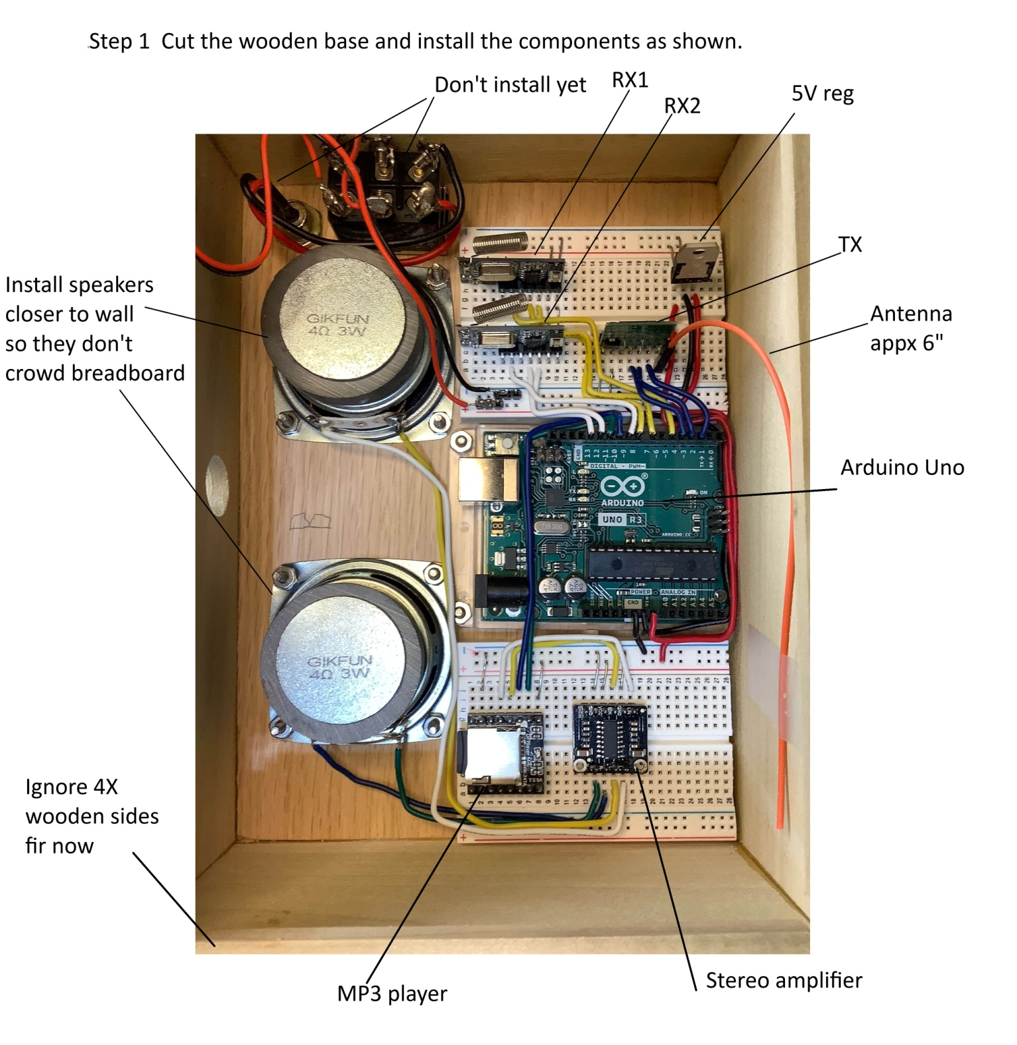
Next, wire the RF breadboard as shown below in Step 2. Note that there are 9 pieces of buss wire used. Two of them are kind of hidden behind the +5V reg and another two (under the yellow wires) connect the +5V power and GND between RX1 and RX1. For a magnified view of this photo click here.
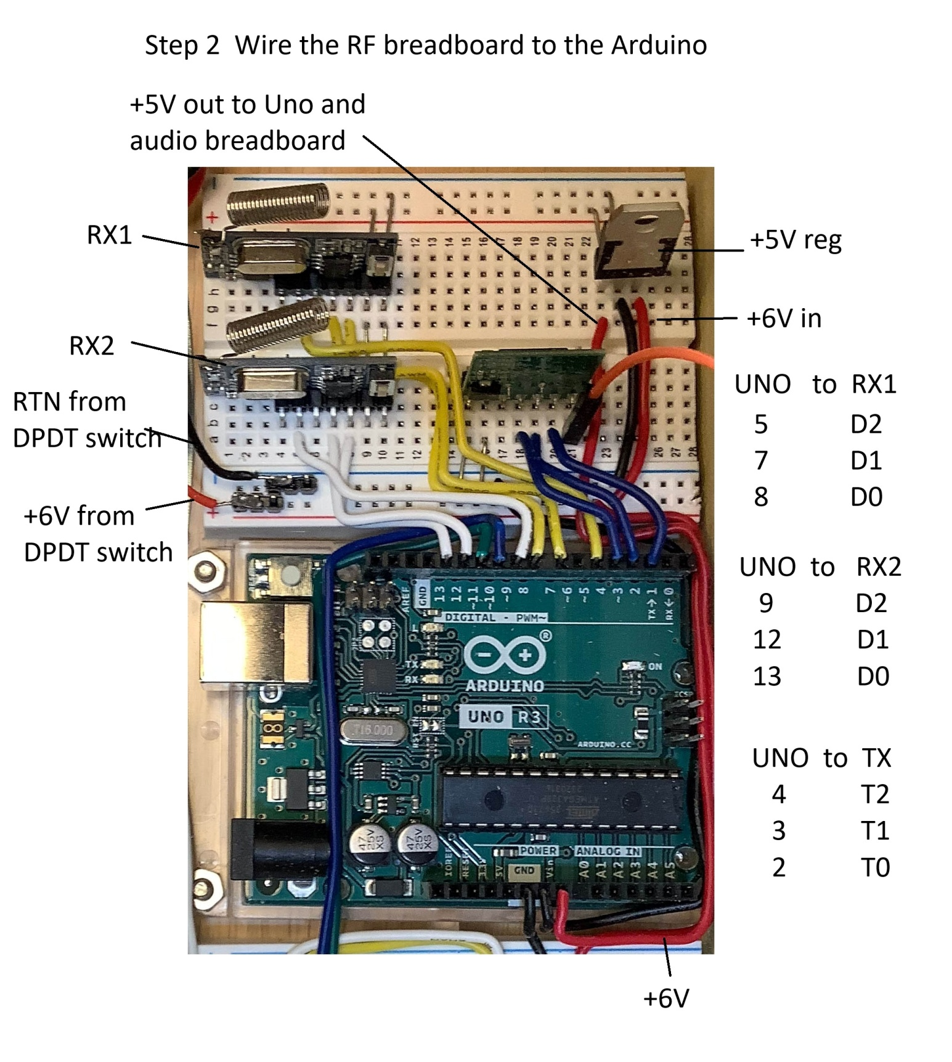
Below is shown the pin assignments for the RX and TX.
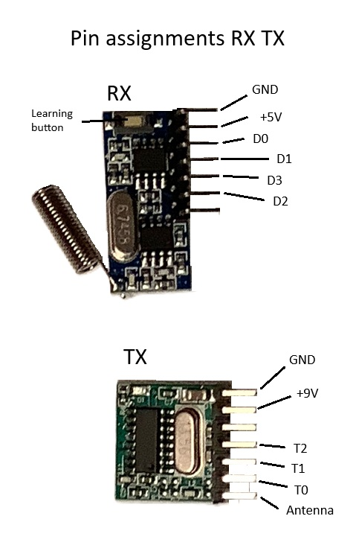
Wire the audio breadboard, the Arduino, and the speakers as shown. Install the MP3 card. Connect the +6V battery and verify the +5V supply, and check to see if the green LED is present on the Arduino.
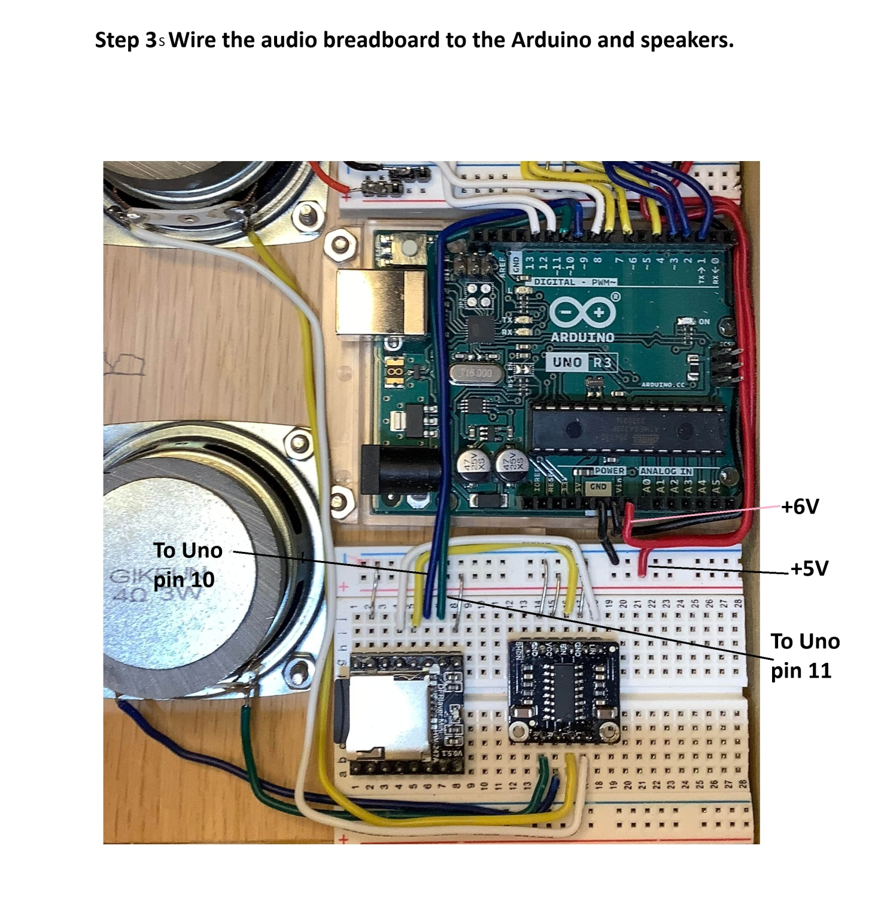
Here's an interconnect diagram that shows the wiring in better detail. I couldn't get Fritzing models for the RX, TX, and dual audio amplifier, so they are shown as outlines. Note the side that the PCB is on for the RX, TX.
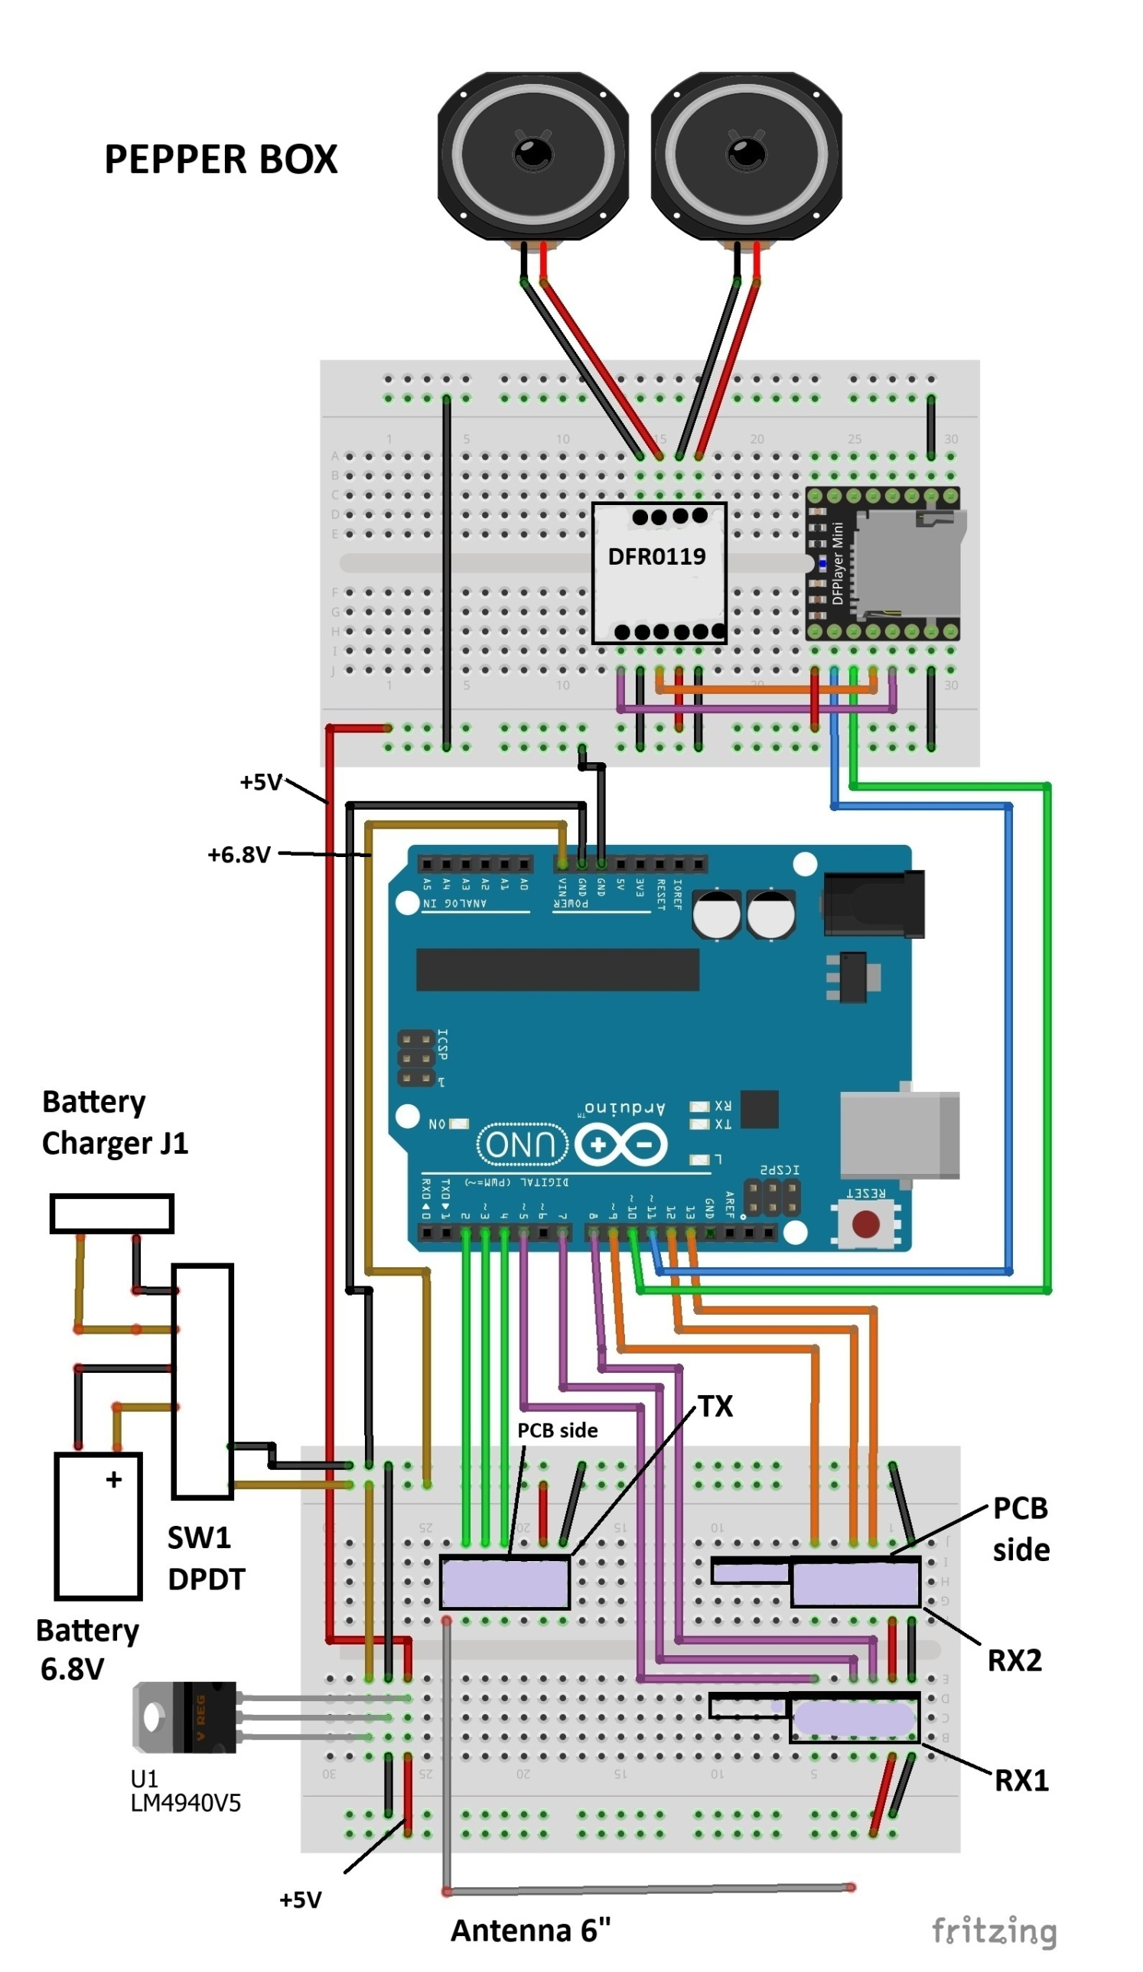
Load the Arduino programs and test. Revise programs if desired
There are three versions of the program; one for each of the three Pepper Boxes (A, B, C). They only differ in what audio clips they play. The overall structure is:
- RX1 receive and store binary word
- Decode and play audio clips
- Transmit signals to next box
- RX2 receive and store binary word
- Decode and play audio clips
- Transmit signals to next box
In normal operation, each box will receive either a RX1 or RX2 signal. In addition, each Pepper Box plays audio clip(s) during set-up (power on).
Below is the section of the code that transmits a two bit binary word (011, 101, 110). A transmit duration of 50ms every 450ms is chosen, and each bit is transmitted 5 times in order to ensure reception at the next Pepper Box. Transmit time is 2.25 seconds, and both the RX1 and RX2 receive times are 1 second. This ensures that if the receiving box is looking for a RX2 signal and a RX1 signal is being transmitted, the program will have time to get to the RX1 receive function before the TX signal stops.
//_____________________________________ transmitter control two digits
void xmit2(int VX, int VY, int VZ) {
for (i=0; i<5; i++) {
if (VX==HIGH) {
digitalWrite(T0, LOW);
delay(50);
digitalWrite(T0, HIGH);
delay(400);
}
if(VY==HIGH) {
digitalWrite(T1, LOW);
delay(50);
digitalWrite(T1, HIGH);
delay(400);
}
if(VZ==HIGH) {
digitalWrite(T2, LOW);
delay(50);
digitalWrite(T2, HIGH);
delay(400);
}
} //________________________end of transmitter control two digits
} // xmit time= 5*2*(.05+.40)sec = 4.5 seconds
The receiver responds to 50ms transmitted signal with a 50ms delay followed by an output lasting about 300ms. To minimize missed bits, when the receiver captures any bit, the program extends the period of time that it is looking. This code is shown below:
//____________________________________________________ RX1 RF signal detector
// reset signal detect, samples and saves any HIGH states
VX=LOW;
VY=LOW;
VZ=LOW;
for (i=0; i<100; i++) {
vx= digitalRead(D0);
vy=digitalRead(D1);
vz= digitalRead(D2);
delay(10);
if (vx==HIGH) { VX=HIGH; }
if (vy==HIGH) { VY=HIGH; }
if (vz==HIGH) { VZ=HIGH; }
} //_______________________________________________________ end of RF signal detect part 1
//_____________________________________________________ extend detect time if any signal is detected
if (VX==HIGH||VY==HIGH||VZ==HIGH) {
for (i=0; i<300; i++) {
vx= digitalRead(D0);
vy=digitalRead(D1);
vz= digitalRead(D2);
delay(10);
if (vx==HIGH) { VX=HIGH; }
if (vy==HIGH) { VY=HIGH; }
if (vz==HIGH) { VZ=HIGH; }
} //_______________________________ end of RX1 RF signal detect part 2
}
Once the receive function has captured a binary number, the program responds by playing one or more MP3 clips and then transmitting a binary number to the next Pepper Box. The sequence of transmitted numbers is:
incoming signal receiver transmitted signal
001 RX1 001
100 RX1 100
001 RX2 010
010 RX2 011
100 RX2 101
101 RX2 110
110 RX2 111
To add a little more complexity, most of the receive functions have alternating functions. For example, the first time Pepper Box A RX2 receives a "010", it plays MP3 clips 47 ("Here's Black Pepper by Micropop") and 88 (plays "Black Pepper). After the "88" clip plays, the pepper box transmits "011" which is received by Pepper Box B.
The next time Pepper Box A RX2 receives a "010" it plays MP3 clips 49 ("Pepper box, black pepper box" - Becky's voice) , 38 ("Made with premium peppercorns" - Steve's voice), then 49, and 49 again. After the last "49" clip plays, the pepper box transmits "011" which is received by Pepper Box B.
if(VZ2==LOW&&VY2==HIGH&&VX2==LOW) { //___________ 0 1 0 code detect
if (w>2) {w=1;}
if(w==1) {
myDFPlayer.playMp3Folder(47); //_here's Black Pepper by Micropop
delay(4000);
myDFPlayer.pause();
myDFPlayer.playMp3Folder(88);//___Black Pepper Micropop
delay(31000);
myDFPlayer.pause();
VZ=LOW; VY=HIGH; VX=HIGH;
transmit(VX,VY,VZ);
VZ=LOW; VY=HIGH; VX=LOW;
}
if(w==2) {
myDFPlayer.playMp3Folder(49);//pepper box, black pepper box
delay(4000);
myDFPlayer.pause();
myDFPlayer.playMp3Folder(38);//made with premium peppercorns
delay(4000);
myDFPlayer.pause();
myDFPlayer.playMp3Folder(49);//pepper box, black pepper box
delay(4000);
myDFPlayer.pause();
myDFPlayer.playMp3Folder(49);//pepper box, black pepper box
delay(4000);
myDFPlayer.pause();
VZ=LOW; VY=HIGH; VX=HIGH;
transmit(VX,VY,VZ);
VZ=LOW; VY=HIGH; VX=LOW;
}
Please note that the code above includes a delay( ) during which the MP3 clip plays. This ensures that the audio plays for the correct amount of time and that the transmission to the next pepper box doesn't occur until the audio finishes. When you modify the program to add your own sound clips, you should also adjust the length of the delay( ). Some of the existing delays are pretty long. For example, "Ghost Riders in the Sky" by the Highwaymen takes 3 minutes and 15 seconds. During test, if these sound clips are not installed, there will be a silent period lasting 3 minutes and 15 seconds. Don't worry! The program is still working.
Note that you can set the volume globally: here's the place in setup. 30 is the maximum. I've tried to keep the amplitude in the MP3's constant so volume only needs to be set once, rather than for each MP3.
Serial.println(F("DFPlayer Mini online."));
delay(2000);
myDFPlayer.volume(20); //_____________________________Set volume value.
Testing is best accomplished in stages. Once one set of circuits has been installed on its base and wired, power it up. Install the Arduino software for Pepper Box A. You should hear the startup message(s). For Pepper Box A the messages are clip 21 "Do we have to hear about his stupid dog dream again?" - Becky's voice followed by clip5 "Did you say something? I thought I heard something." -Steve's voice. These messages will play each time the Arduino program executes setup.
The next test to perform is to trigger the Pepper Box A using the remote. On the "A" section of the remote control press the switch for "001". The box will play MP3 clip 41 "I'm sorry, you can't stand here; this is where the dogs come ashore" - Steve's voice. A silence will follow unless you have installed a clip 100 ("Pepper" on my machine) in which clip 100 will play.
Press switch "001" again and you will hear clips1 and 15 (Birds) followed by clip20 "Is that those damn birds again" - Becky's voice. Repeat with switch "100". The first time you will hear clips 2 and 16 (more birds) followed by clip 5 ("Did you say something.......") - Steve and then clip 20 ("Is that those......") - Becky. The second time you press "100" you will hear clip 32 ("That devilhead is ........") - Steve's voice. This is about as far as you can go in testing until more Pepper Boxes are built.
As you finish other boxes, test them the same way; of course the MP3 clips will be different. Finally, check that the boxes interact properly. Pushing a "001" button on the remote control will start an interaction of 4 boxes, for example A to B to C to A again. A "100" button will result in an interaction of 5 boxes, for example B to C to A to B to C again.
- Complete the wooden boxes and install the remaining parts
Before gluing the boxes together, there are two things that need to be done. First, drill a 5/8" hole in 3 of the side panels. This hole will allow the Arduino cable to plug in without removing the front panel. The location is shown in the photo below. Second, glue the 1/4" X 1/4" spacers as also shown in the photo. The front panel will mount against these so use some scrap 1/4" material to space them properly before gluing them. If they're a little more than 1/4" below the lip, an orbital sander is your friend.
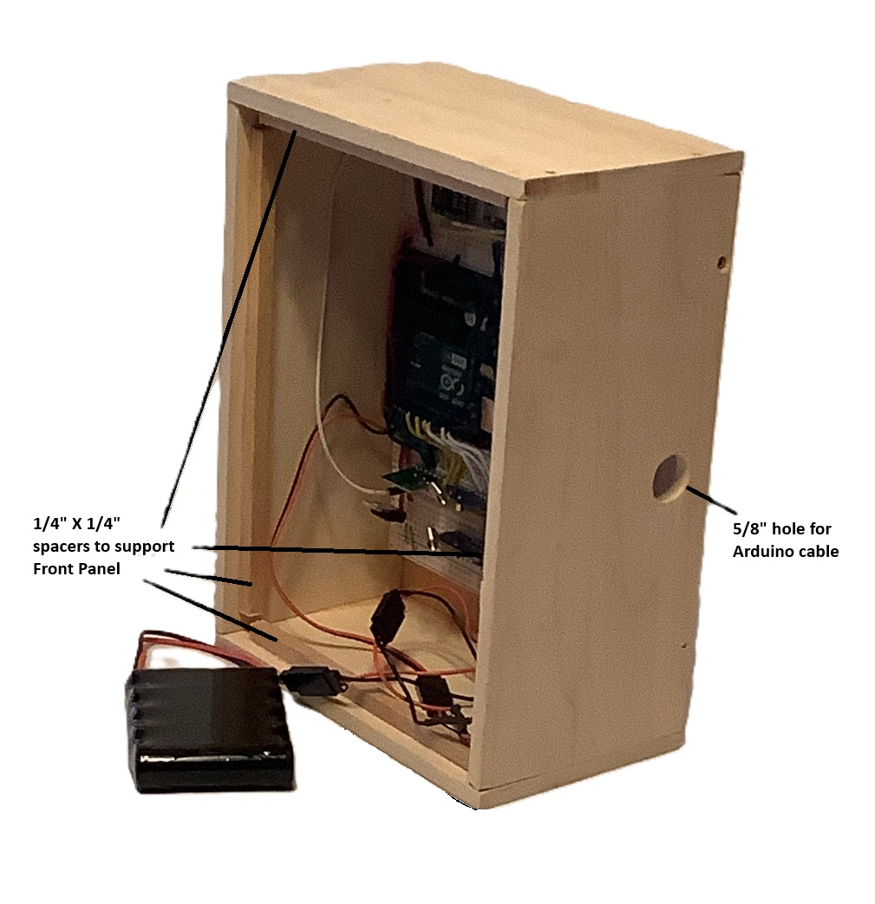
Now glue the box together - Remember DO NOT glue the front panel into the box. It must be removable. That's what the 1/4" spacers are for; to support it. I glued the box together in two steps. The first step was to glue the two side panels to the base. I applied a small amount of glue to the long edges with the base. Next, lay the base down on some waxed paper on a flat surface. Then, apply some glue to the mating surfaces of the side panels and press them against the base. Next, I leaned the two end panels in place and put the front panel against the 1/4" spacers. This ensures that the box will fit together and the front panel will fit also.
After the glue dries, apply glue to the other joints and finish the glue operation. After the glue set, I put a few tiny brass flat head wood screws to give the glue some extra help. I have no idea if this is necessary. After this, the box can be finished off with an orbital sander to smooth out any protruding edges.
To finish assembling the electronic parts, install the battery charger connector and solder the wires to one side of the DPDT power switch. . I wanted the battery to be removable so I connected it to the center pins of the switch thru a servo connector. Next, connect the last side of the switch to the RF breadboard as shown above. To finish, install the power switch such that when the toggle is facing the battery charge connector, the battery is connected to the jack.
To complete the boxes, I enlarged a photograph of a pepper container and printed it on 81/2" X 11" vinyl sticker paper for inkjet printers. Cut the print to exactly cover the front of the pepper box. The adhesive on the vinyl paper will hold the front of the box in place, but it can be easily removed if needed.
- Enjoy the awesome results
What's fun is spreading out the boxes in your living room and triggering one of them with the remote control. Sit back and enjoy! If you're bored or patient, you can listen to all 12 sequences in one sitting. Just keep pushing the buttons!
Code
Pepper Box A
Arduino code for Pepper Box A
redfescue/Pepper

Contains documents for giant pepper box project/ Read More

Latest commit to the master branch on 10-01-2026
Download as a zip
Pepper Box B
Arduino code for Pepper Box B
redfescue/Pepper

Contains documents for giant pepper box project/ Read More

Latest commit to the master branch on 10-01-2026
Download as a zip
Pepper Box C
Arduino code for Pepper Box C
redfescue/Pepper

Contains documents for giant pepper box project/ Read More

Latest commit to the master branch on 10-01-2026

